Essential Unit Guiding Question

How do authors develop characters?

Lesson Guiding Questions

What is characterization? How do authors use characterization to create and develop characters?

Lesson Overview

This two-part lesson focuses on the ways in which authors reveal characters through methods of characterization, specifically through revealing what a character looks like, says, does, thinks and feels, and what others say about the character. In this lesson, students will also gain practice with making inferences. Teachers first model examples of methods by using the text “Eleven” by Sandra Cisneros (or another reading selection). After modeling, students identify textual examples of characterization in a longer work. Text dependent questions around the story “Eleven” are included in this lesson so students can experience close reading of this text to examine other story facets besides characterization.

ELA COMMON CORE Standards

* Read closely to determine what the text says explicitly and to make logical inferences from it; cite specific textual evidence when writing or speaking to support conclusions drawn from the text (R.CCR.1).
* Analyze how and why individuals, events, and ideas develop and interact over the course of a text (R.CCR.3).
  + Analyze how particular elements of a story or drama interact (e.g., how setting shapes the characters or plot) (RL.7.3).
  + Analyze how particular lines of dialogue or incidents in a story or drama propel the action, reveal aspects of a character, or provoke a decision (RL.8.3).
  + Analyze how complex characters (e.g., those with multiple or conflicting motivations) develop over the course of a text, interact with other characters, and advance the plot or develop the theme (RL.9-10.3).
  + Analyze the impact of the author’s choices regarding how to develop and relate elements of a story or drama (e.g., where a story is set, how the action is ordered, how the characters are introduced and developed) (RL.11-12.3).

PART 1: MODEL with story

Resources

* “Methods of Characterization” (Figure 8.4)
* “Characterization: ____” (Figure 8.5)
* “Characterization: Rachel” (Figure 8.6)

Timing

This lesson occurs in approximately two 1-hour class periods.

Lesson Details

1. ***Pose guiding questions and set the stage for the lesson.***

* Remind students that there are five elements of literature: *theme, plot, setting, point of view,* and *character.* Tell them that as they read, they will focus on the element of *character.*
* Ask students to brainstorm answers to these guiding questions: ***How do authors develop characters? What does an author do to help readers learn about characters?*** Record students’ responses so they are visible to the class. Then introduce (or review) the definition for characterization: **the term used for the methods an author uses to create or develop a character.** Distribute Figure 8.4 “Methods of Characterization” and feature it on the document camera or overhead. Have students compare this figure with the class brainstormed list. Discuss differences and validate similarities. Tell students that they will be focusing on various methods of characterization as they listen to and read Sandra Cisneros’ story “Eleven” (or another featured text). Explain that later they will individually investigate methods of characterization for a longer work of literature.

2. ***Reveal examples of each method of characterization.***

* To illustrate how Sandra Cisneros uses methods of characterization, tell students you will read the story “Eleven” aloud. Then together you will record examples that are used for the character Rachel onto Figure 8.5 “Characterization: ___.” For this exercise, place this figure on the document camera or make a transparency of it for an overhead. Since you will focus on Rachel, write her name in the blank after “Characterization.”
* Begin recording text excerpts onto the figure by first using the think aloud strategy. Then solicit students to contribute text examples for each method and record their information. If students are reluctant to share, refrain from calling on just a few students. Rather, involve more students in the discussion by isolating one method of characterization at a time and asking students to work in trios to find text examples before sharing with the whole class.
* “Characterization: Rachel” includes partial entries you and students might make. There are other ones, as well, so record several examples in each row that apply. When completing the sheet, note that there are not as many examples of physical appearance. At this point you will leave the 3rd column for “Personality Traits” blank.

3. ***Infer personality traits from recorded text examples.***

* Explain to students that they will use what they have gleaned from the quotes they identified about Rachel to make inferences about her personality. Explain that making inferences can be tricky because the author is not presenting readers with information explicitly. Rather, readers draw inferences by using the information from the text to draw conclusions and make knowledgeable interpretations. The art of making inferences enriches readers’ experiences because it enables them to arrive at new insights after examining the text critically.
* Review the various examples of quotes from the story that are recorded on Figure 8.5 “Characterization: ___.” After each example—except for the first one on physical appearance—focus on the impression readers glean about Rachel. To do so, reread each text example and ask students to talk in trios to answer: ***What personality trait***

***can you think of to describe Rachel based on this quote from the story?*** Tell them they can use other text evidence not on the characterization sheet to make their inferences. You might first review personality traits to remind students that they are expressed as adjectives. Rattle off a few examples to get them thinking: *caring, responsible, conceited, rude, loyal.*

* Invite trios to share and support their impressions of assigned traits of characters using textual evidence. Discuss commonalities among students’ input and arrive at a class consensus of personality traits associated with Rachel. Take this opportunity to discuss shades of meanings of words. Extend the conversation to other characters in the story: Mrs. Price, Sylvia Saldivar.
* Make the point that through methods of characterization, readers get an overall impression of a character. This is similar to people in our lives develop an overall sense of another individual based on what people say or do.

4. ***Engage in discussion using text dependent questions.*** After discussion about characterization, instruct students to read “Eleven” independently. Then pose the following text dependent questions.

* *What is the significance of counting backwards from eleven? Why is this such an important age for Rachel?*
* *Why does Rachel not want to claim the sweater?*
* *Why can’t Rachel be honest with Mrs. Price about the sweater? Why is she so shy and reluctant?*
* *Why does Cisneros use the hyperbole of one hundred and two?*
* *What are examples of simile that Cisneros uses in “Eleven”? What are the comparisons in each example? How does each example of simile convey information about Rachel’s character?*
* *What are examples of repetition in “Eleven”? Identify and examine specific words and also phrases that are repeated. What effect does repetition serve in the story?*
* *From whose point of view is “Eleven” told? How does it create a more impactful story than if told from a different perspective?*
* *Cisneros uses the metaphors of an onion, rings of a tree trunk, and stacking dolls to describe growing old. Reread that paragraph and rewrite it in your own words.*
* *Why does Rachel write in the second to the last paragraph: “…it’s too late”? What tone is conveyed in this paragraph?*
* *The story is a combination of interior monologue and dialogue. Does one device carry more impact than the other?*
* *Add other questions focusing on standards that relate to the story.*

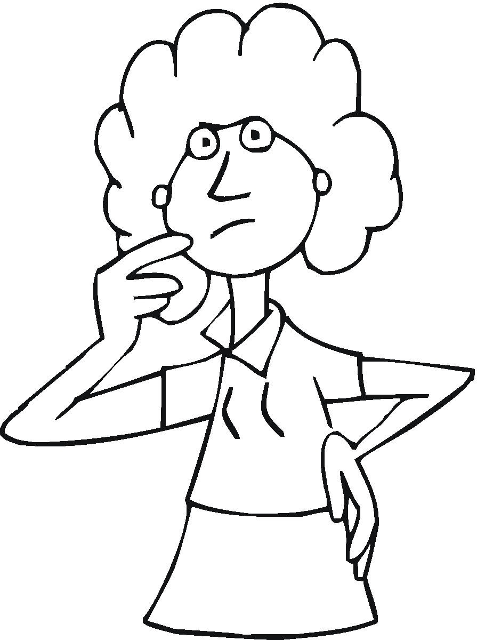**Methods of Characterization**

|  |
| --- |
| What a character says  (speech and dialogue) |
| What a character looks like  (physical appearance and clothing) |
| What a character thinks or feels |
| What others say  about the character |
| What a character does (actions and behavior) |

****Figure 8.4

Copyright © 2013 by Corwin. Reprinted from *Mapping Comprehensive Units to the ELA Common Core Standards, 6-12* by Kathy Tuchman Glass.

**CHARACTERIZATION for ___________________**

**How do authors develop characters?**

|  |  |  |
| --- | --- | --- |
| **Method of characterization** | **Example** | **Personality Trait** |
| What a character says |  |  |
| What a character looks like |  |  |
| What a character thinks or feels |  |  |
| What others say about the character |  |  |
| What a character does |  |  |

Figure 8.5

Copyright © 2013 by Corwin. Reprinted from *Mapping Comprehensive Units to the ELA Common Core Standards, 6-12* by Kathy Tuchman Glass.

**Characterization: *Rachel***

**How do authors develop characters?**

|  |  |  |
| --- | --- | --- |
| Character Method | Support | Personality Trait |
| **what the character looks like** (describe the character’s physical traits) | *Maybe because I'm skinny…*  (“Eleven” by Sandra Cisneros, p. 7) |  |
| **what the character says** (report the character’s speech and dialogue) | *"That's not, I don't, you're not . . . Not mine." I finally say in a little voice that was maybe me when I was four.*  (Cisneros, p. 7) |  |
| **what the character does** (report about the character’s actions and behavior) | *I move the red sweater to the corner of my desk with my ruler. I move my pencil and books and eraser as far from it as possible. I even move my chair a little to the right.*  (Cisneros, p. 8) |  |
| **what the character thinks and feels** (reveal the character’s thoughts and feelings) | *In my head I'm thinking how long till lunchtime, how long till I can take the red sweater and throw it over the schoolyard fence, or leave it hanging on a parking meter, or bunch it up into a little ball and toss it in the alley.*  (Cisneros, p. 8) |  |

Figure 8.6

Copyright © 2013 by Corwin. Reprinted from *Mapping Comprehensive Units to the ELA Common Core Standards, 6-12* by Kathy Tuchman Glass.

PART 2: INDEPENDENT WORK with longer text

Resources

* Novel (or short story)
* “Characterization: ________” (Figure 8.5)
* “Character Traits” (Figure 8.7)—3 versions: ♥ struggling learners, ♣ at-grade level, ♠ high achievers

Timing

Independent practice after reading Chapter 5 This lesson occurs in approximately a 1-hour class period.

Lesson Details – PART 2: INDEPENDENT PRACTICE

1. ***Connect to previous learning in Part 1.***

* Say to students: *“During the discussion around the story ‘Eleven,’ you were introduced to methods of characterization. We examined examples from the story that support methods of characterization for Rachel and then we used those text quotes to infer personality traits. Now you will do the same for characters in a novel as we continue to address the guiding question:* How do authors develop characters?*”*
* Note to teacher: For this part of the lesson, students examine how authors develop characters using a class novel, one they are reading in literature circles, or a novel they read independently. Even though students select novels based on interest, insure that this novel is appropriately challenging for each student as well so all can wrestle with complex texts to improve their reading competencies.

1. ***Identify examples of characterization for a character in the novel; infer personality traits.***

* Distribute a copy of Figure 8.5 “Characterization: ____” that was used in Part 1; feature it on the document camera or overhead, as well. Tell students they will find examples for each (or most) of the five methods of characterization for a designated character in a novel and record their findings on this figure. This is an ongoing exercise, so make available several copies of this figure for students to use as they experience their novels.
* As they did before, have students identify personality traits that are associated with pertinent methods of characterization. Let them know they will have to defend their impressions of these characters with classmates based on textual evidence. You might distribute “Character Traits” in Figure 8.7 and conduct exercises around these words so students expand their inventory of vocabulary and use these and other words to identify a character’s personality.
* **Differentiation**. Instruct all students to complete the “Characterization: __” handout for the novel’s protagonist. For more advanced students, assign additional characters that are appropriately challenging. Scaffold support for struggling learners by preparing some quotes in advance that they can match to methods of characterization. For personality traits, distribute a “Character Traits” sheet (D) to students based on readiness levels: ♥ struggling students, ♣ at-grade level, and ♠ high achievers.

1. ***Discuss entries and claims.***  This is an ongoing assignment for the duration of the novel. Periodically set aside class time for students to hold discussions in various grouping configurations (e.g., pairs, small groups, whole class) about quotes they entered and their impressions about characters. Their discussions should center on textual evidence as they support claims they make.

* **Differentiation**. If students are reading books in literature circles, group them based on their selected novels. If they are reading different books, they can still work in groups to share their impressions and cite evidence. It might prompt them to read each other’s books as they learn about characters in various reading selections.

1. ***Write brief argument.***  For a formative assessment, have students write a brief argument of a paragraph in which they use textual evidence from the novel to address any of these prompts:

* Defend a trait a character possesses and evidence to support it.
* Argue for how a particular action a character takes impacts the plot.
* Give your rationale for why the author included a particular section of dialogue and how it affects the plot.

As is the purpose of formative assessment, use students’ responses in this paper to inform your instruction. At the end of this novel study, students can write a formal argumentation essay as a summative assessment.

Assessments

* Participation in paired, group, and class discussions
* “Characterization for _____”
* Argument paragraph

**♥ Character Traits ♥**

|  |  |  |  |
| --- | --- | --- | --- |
| adventurous  bashful  bossy  careful  careless  clumsy | cowardly  cruel  distrustful  foolish  gentle  helpful | hopeful  innocent  loving  loyal  moody  practical | secretive  sincere  skillful  stubborn  ungrateful  wise |

**♣ Character Traits ♣**

|  |  |  |  |
| --- | --- | --- | --- |
| aggressive  capable  clever  comical  confident  energetic | fierce  heroic  humble  impatient  insincere  irresistible | knowledgeable  modest  overbearing  reasonable  sociable  suspicious | thrifty  timid  trustworthy  unfaithful  vain  wholesome |

**♠ Character Traits ♠**

|  |  |  |  |
| --- | --- | --- | --- |
| aloof  anxious  apathetic  bitter  boisterous  dignified  exceptional  frail | gullible  haughty  humane  imaginative  incompetent  ingenious  inventive  morbid | nonchalant  optimistic  passive  pessimistic  radiant  rebellious  resilient  sarcastic | sentimental  spontaneous  treacherous  unruly  unyielding  villainous  vivacious  vulgar |

Figure 8.7

Copyright © 2013 by Corwin. Reprinted from *Mapping Comprehensive Units to the ELA Common Core Standards, 6-12* by Kathy Tuchman Glass.